

Clinical Guideline for:
Epidural/ Patient Controlled Epidural Analgesic (PCEA) Infusion in Children
Summary

These guidelines apply to those children who require epidural infusion as part of their pain management plan and include:
- Background, indications and contraindications
- Equipment for infusion
- Prescriptions
- Administration and monitoring
- Dressing change
- Epidural Catheter Insertion and Removal
- When to call for urgent review (Pain Nurse or Anaesthetist on-call)
- Discontinuing the epidural
- Troubleshooting of side effects and complications associated with epidural infusions

Introduction
The following guidelines apply to those children who require epidural analgesic infusion as part of their pain management plan.

Guidelines for the Administration of Epidural Analgesia
- Background and Indications
  - Epidural/PCEA infusion of opioid and/or local anaesthetic is well documented for the management of pain.
  - An epidural infusion may be used for:
    - abdominal surgery
    - thoracic surgery
    - lower limb amputation
    - lower limb major joint surgery
    - trauma
    - rib fractures
    - intractable pain in terminal disease e.g. cancer, ischaemic limb pain
  - Patient selection is determined by an anaesthetist. The anaesthetist is responsible for obtaining patient consent for the procedure. The epidural must be inserted by a paediatric trained senior anaesthetist.

- Contraindications
2.1 Absolute
    - coagulopathies
    - local sepsis
    - allergy to drugs used
    - raised intracranial pressure
    - unstable spinal fractures
    - patient/parent does not give consent
2.2 Relative
    - hypovolaemia
    - pyrexia or septicaemia
    - aortic/mitral stenosis
    - neurological disorders

Note: anticoagulation – there may be an absolute or relative contraindication dependent upon the anticoagulant prescribed. The anaesthetist will need to take this into consideration when reviewing the child for an epidural (see section 8.4)

- Equipment for Infusion
  - The system consists of a narrow-bore catheter with a yellow antibacterial filter and a 250ml fluid bag containing the prescribed drugs. Bags are ordered from Pharmacy. The bag label is coloured yellow.
  - The administration set, connecting the fluid bag, is coloured clear with a yellow stripe. This is to help prevent confusion with intravenous lines. NRFit was introduced in 2022, to avoid inadvertent IV injection.
  - Specific pumps are used for epidural infusions – CME Bodyguard 545.
  - The registered nurse responsible for caring for a patient with an epidural infusion must be trained and assessed as competent in the use of equipment.
  - Infusion bags must be kept separate from IV infusion bags, preferably in a locked cupboard or fridge.

- Prescription
  - Pre-operative education is essential. Children and parents must be introduced to the risks and benefits of epidural analgesia by the anaesthetist and given the opportunity of reading the information leaflet. Nursing staff in Recovery and on the ward area will reinforce this information.
  - The epidural infusion is prescribed on the child’s MAR chart. Suggest, as per Bristol Royal Infirmary guidance, to administer at 0.1-0.4ml/kg/hour to a maximum of 15ml/hr.
  - PCEA (patient controlled epidural analgesia) can be considered in children over 40kg and 12 years of age.
  - Opioids via other routes should not be given alongside epidural opioid infusion without discussion with the anaesthetist or Pain Team.
  - An antiemetic and naloxone should be prescribed if the epidural infusion contains an opioid.
  - Advised naloxone dose:
- 1month – 12 years (less than 50kg): 5-10microgram/kg repeated after 2-3 minutes as required;
- 12-18 years (50kg and over): 50-100microgram repeated every 2-3 minutes as required.
  - Non-opioid analgesia should also be prescribed regularly unless contraindicated.
  - Night sedation may be given on consent of the anaesthetist. Be aware that this can increase sedation.
  - Pre-prepared bags must be ordered from pharmacy and used and are provided with the following doses:
    - Bupivacaine 0.1% with 2mcg/ml fentanyl, 250ml bags.
    - Bupivacaine 0.125% with 2mcg/ml fentanyl (250ml and 500ml bags)
    - Bupivacaine 0.125% 250ml bag.
    - Bupivacaine 0.15% 250ml bag
Please note bag volumes may vary, due to stock issues.
- Administration
  - The Nurse in charge of the ward area must inform the anaesthetist if there is inadequate ward staffing to care for a child with an epidural.
  - Epidural in a child or Young person currently aligns to the Level 2 PCCS standards (2021) and should be nursed, where possible within a HDU environment.
  - The nurse responsible for the care of the child must be a registered nurse who has completed epidural training and been assessed as competent
  - The child must have a patent intravenous cannula sited for the administration of any emergency fluids or drugs. Care for the cannula as per Trust policy. Liaise with the Consultant Anaesthetist who inserted the epidural if the cannula fails as regards need for re-cannulation.
  - This is a high-risk infusion and 2 members of staff are required to check out the appropriate drug filled bag, check the patient and check the relevant pump on commencing infusion/changing syringes
  - Epidural bags should be kept in a locked cupboard, separate from PCA syringes and IV fluid bags.
  - Epidural bags should be changed at least once every 24 hours.
  - The epidural administration set should be changed every 72 hours. Label line with date and time commenced.
  - The epidural bag should be checked against the prescription at each handover between staff caring for the patient.

- Monitoring
For complex patients with pre-existing decrease in motor function – record a pre-operative motor response level on the Paediatric Advanced Analgesia Monitoring Chart on MyCare.

  - Specific observations are essential – refer to ‘Guidelines for Monitoring’. Use a Paediatric Advanced Analgesia Monitoring Chart tab. Monitoring of the patient is the responsibility of the registered nurse in charge of the care of the patient.
  - The level of sensory block can be checked by using the child’s response to cold. This is achieved using cold water or ice in a disposable glove.
  - The epidural catheter insertion site must be checked at least 8 hourly for inflammation and leakage. The first check will be performed and documented in Recovery. Inform the Pain Nurse or anaesthetist on-call if the site is inflamed or if there is excessive leakage. The site must also be checked at least once a day once the epidural had been removed and the Pain Nurse/anaesthetist on-call contacted if the site becomes inflamed. Document and inform Pain Nurse/anaesthetist on-call and the surgical team if the site is covered and difficult to see e.g. child with hip spica.
  - Check motor block as per monitoring guideline and prior to mobilising. The patient can mobilise if there is no excessive sensory/motor block but must be under the direct supervision of a member of staff. Limb weakness is more likely with lumbar epidurals. Inform the Pain Team or anaesthetist on-call if the child cannot move one or both legs.
  - Check pressure areas every 6 hours and document this on MyCare.
  - Perineal numbness is common with epidural analgesia. Patients with urinary catheters should be examined regularly to ensure that the catheter apparatus is sited comfortably. In particular, it should not be stretched, twisted or laid upon.
  - Ensure that the filter/line connection is wrapped with a transparent dressing to reduce the risk of disconnection.

- Dressing Change
  - The dressing should only be changed if there is pooling or leakage beneath the original dressing or if there is a risk of the epidural site becoming uncovered. If concerned, discuss with the Pain Nurse/Anaesthetist on-call prior to changing the dressing.
  - If a lock-it has been used, leave this in situ.
  - Dressing change is a strictly aseptic procedure – sterile gloves must be used.
  - The epidural catheter insertion site must be covered by a sterile, transparent dressing
  - The sterile dressing should be covered with mefix, leaving a ‘window’ so that the epidural site can be observed.
  - Document in the child’s notes and inform the Pain Team/Anaesthetist on-call that the dressing has been changed.

- Epidural Catheter Insertion and Removal
  - Epidural catheters are inserted by anaesthetists following departmental guidelines.
  - Epidural catheters can be removed by a registered nurse who has completed epidural training or by a member of nursing staff under the supervision of a registered nurse who has completed epidural training.
  - The epidural catheter should be removed by the end of the third post-operative day unless discussed with the anaesthetist who inserted the epidural or, in their absence, the pain management team or anaesthetist on-call.
  - Anticoagulation:
- Please refer to Table One on Page 11
- contact the Pain Nurse or Anaesthetist if any other type of anticoagulation is used or if there are concerns regarding anticoagulation
  - Removal of the epidural catheter is an aseptic procedure.
  - Position the child in a slightly flexed position either sitting forward or lying on their side.
  - Remove dressings.
  - Apply gentle traction to the catheter. If there is difficulty in removing the catheter, contact the Pain Nurse or anaesthetist on-call.
  - Ensure that the catheter is intact and that the tip is present.
  - Cleanse the skin around the site using a skin cleaning agent e.g. ChloraPrep stick after removal.
  - Apply a sterile dressing to the site. Remove this dressing after 24 hours.
  - Send the catheter tip for microscopy, culture and sensitivity if there are signs of inflammation at the site and/or pyrexia.
  - Monitor the site at least once daily whilst the child is in hospital.
  - Encourage the child/parent to report any pain at the site or increasing back pain, or increased weakness in legs once the epidural has been removed.

- When to call for urgent review (Pain Nurse or Anaesthetist on-call)
  - High level sensory block above T4 i.e. decreased response to cold above nipple line or weakness in arms.
  - Dense motor block of one or both legs (see appendix one for management of leg weakness)
  - Suspected infection or excessive leaking at the epidural site.
  - Severe pain.
  - Disconnection of the epidural catheter from the filter.

- Discontinuing the epidural
  - The epidural should not be removed within 24 hours of insertion without discussion with the anaesthetist.
  - It is not advised that the epidural is ‘weaned’ prior to removal. Preferred method is to stop the infusion and cap off the catheter using a red hub. Administer alternative analgesia and assess its effectiveness. If the child is comfortable after four hours then epidural catheter can be removed as per guidelines. If the child complains of severe pain then contact the on-call anaesthetist or pain nurses.
  - Ensure prescribed non-opioid analgesics have been administered.
  - Ensure suitable supplementary analgesics have been prescribed prior to stopping the epidural.
  - Other opioids can be administered once the epidural has been stopped. The child will need to be monitored for opioid related side effects, particularly sedation and respiratory depression.
  - If the epidural has been cited for 3 days and the patient is unable to tolerate oral analgesics – discuss with the Pain Team or anaesthetist on-call.
  - Inform the Pain Nurse or anaesthetist on-call if this is continuing sensory or motor block six hours after removal of the epidural catheter.

Troubleshooting of Side Effects and Complications Associated with Epidural Infusions

- Poor Analgesia
  - Check the catheter insertion site for excessive leakage and migration of the catheter i.e. is the catheter still in the epidural space?
  - Check for accidental disconnection. Do not reconnect, inform pain team or on call anaesthetist (See section 10)
  - Give prescribed non-opioid analgesics.
  - Consider increasing the infusion rate.
  - If the pain is severe, contact the Pain Nurse or anaesthetist on-call immediately.
  - If the child requires a bolus dose (administered by anaesthetist):
- The blood pressure must be recorded every 5 minutes for 30 minutes following the bolus dose. Sympathetic blockade may lead to hypotension due to vasodilation.
- Treatment of hypotension is usually by the intravenous infusion of prescribed IV fluid.
- The sensory level block should be checked and documented 30 minutes following a bolus dose.

- Sedation and Respiratory Depression
  - If the respiratory rate drops below the accepted rate for that child or the child is unrousable, stop the infusion, give oxygen to maintain SpO2 above 94% and administer naloxone as prescribed. Call for urgent medical review.
- Nausea and Vomiting
  - Administer prescribed antiemetic therapy.
  - Consider other causes of nausea/vomiting e.g. ileus, obstruction.

- Hypotension
  - A bolus of local anaesthetic may result in hypotension in a patient who is hypovolaemic.
  - It is essential to rule out other causes of hypotension e.g. bleeding, hypovolaemia.
  - Epidurals rarely cause hypotension in younger children so it is essential to rule out other causes.
  - Stop the infusion if the blood pressure drops below that expected for the age of the child and inform the Pain Nurse/Anaesthetist on-call/paediatrician. Give prescribed IV fluids. A vasoconstrictor may be indicated following anaesthetic/paediatrician assessment.
  - Check the sensory level block if the BP falls below that expected for the age of the child.
  - Inform the Pain Nurse or anaesthetist on-call it the block is above T4/nipple line or child develops arm weakness. Stop the epidural.
  - Do not place the child in the ‘head down’ position. Legs can be raised.

- Urinary Retention
  - It is advised that the child has an indwelling urinary catheter whilst the epidural infusion is being administered.
  - If the child is not catheterised consider administering a dose of naloxone 0.5microgram/kg IV/IM for child under 50kg
  - Consider administering naloxone 50microgram IV/IM for a child 50kg or over.

- Pruritis
  - Administer naloxone 0.5microgram/kg IV/IM for child under 50kg (maximum 4 doses, 5 minutes apart).
  - Administer naloxone 50 microgram IV/IM for child 50kg and over.
  - Consider reducing the epidural rate if pain control is good or removing the opioid from the epidural infusate.

- Dural Tap Headache
  - Incidence of dural tap should be documented on the anaesthetic chart.
  - Typically, the headache is worse on sitting/standing
  - Lie child in a comfortable position – flat or semi-recumbent.
  - Keep the child well hydrated.
  - Give paracetamol unless contraindicated.
  - Inform the Pain Team or anaesthetist on-call.

- Epidural Site Infection
  - Check epidural site at least 8 hourly for signs of infection whilst the epidural is sited and at least once daily once it has been removed.
  - Inform Pain Nurse or anaesthetist on-call if concerned about epidural site infection.

- Epidural Haematoma or Abscess (medical emergency)
  - Monitor sensory and motor block as per Monitoring Guidelines.
  - Inform the Pain Nurse or anaesthetist on-call immediately of:
- Motor block score of 2 or 3 in one or both legs.
- Severe back pain
  - Ensure child and/or parent are aware of these symptoms as abscesses can form days after removal of the epidural catheter.

- Disconnected Epidural Catheter
The filter helps to prevent the injection of bacteria and small particles into the epidural space. It is attached to the epidural catheter via a yellow connector which locks the catheter in place at one end and attaches to the filter via a luer lock at the other end. It is possible for disconnection at either end of this connector. If this happens –
DO NOT RECONNECT THE CATHETER AS THE RISK OF INFECTION INCREASES.
Action in event of disconnection:
- If the epidural catheter disconnects from the yellow connector: wrap the patient end of the catheter in sterile gauze and contact the Pain Team or on-call anaesthetist immediately
- If the filter disconnects from the yellow connector at the luer lock: attach a red bung to the end still connected to the patient and contact the Pain Team or on-call anaesthetist immediately.
The decision to reconnect an epidural catheter to a new filter is the decision of a senior anaesthetist. An anaesthetist or Pain Nurse can reconnect the catheter if disconnection has been witnessed. This is an aseptic procedure where the epidural catheter is cleansed with chlorhexidine/alcohol swab, cut and aseptically connected to a new filter. The catheter should be permitted to ‘dry’ for 2 minutes before cutting and reconnection and new sterile gloves must be worn prior to cutting the catheter. Note: chlorhexidine and alcohol are neurotoxic.

- Associated guidelines and policies
- Medicines Management
- Infection Control
- Paediatric Resuscitation Guideline
- RCA (Royal College Anaesthetists) Epidural Guideline
- Paediatric Critical Care Society (2021) Quality Standards for the Care of Critically Ill or Injured Children. Available from: https://pccsociety.uk/wp-content/uploads/2021/10/PCCS-Standards-2021.pdf
- Management of Leg Weakness with Epidural Analgesia
- AAGBI Local Toxicity Guideline

- Publication Details

Author of Clinical Guideline | Senior Nurse Specialist, Pain Team
Directorate/Department responsible for Clinical Guideline | Pain Management
Contact details | Ext: 6938. Bleep 354  Lucy.price2@nhs.net
Date written | Revised 09/02/2015; Revised 20/10/2016; Revised 30/12/2019; 21/07/2020; 12/05/2021
Approving body and date approved | Paediatric Governance 10/11/2020  Pain Governance 12/05/2021  Reviewed by Dr Philippa Dix, Lead Paediatric Anaesthetic Consultant
Review date | January 2026
Expiry date | 26/04/2026
Date document becomes live | 07/06/2023

Appendix One

Management of leg weakness with epidural analgesia
Increasing leg weakness
Motor score 2 or 3 in one or both legs
2 = can move foot and ankle only
3 = full leg paralysis
No
Urgently, contact the Anaesthetist on call on bleep 485. Proceed to MRI scan.
An epidural haematoma has to be evacuated within 8 hours of the onset of symptoms for your patient to have the best chance of recovery of neurological function.
Do not delay.
YesS
Suspect an epidural haematoma. Proceed as follows
Patient Comfortable?
Recommence epidural infusion at a reduced rate
Yes
No
Contact the Pain Team or out of hours the on call Anaesthetist to reassess the patient’s analgesia
No
Yes
More than 4 hours since stopping epidural infusion?
Leg strength improving?
Reassess leg strength every
30 mins
Switch epidural off
Immediately notify the Pain Team
on Bleep 354
Out of hours the On-call Anaesthetist on Bleep 485

Table One - Recommendations related to drugs used to modify coagulation. Recommended minimum times are based in most circumstances on time to peak drug effect + (elimination half-life 9 2), after which time < ¼ of the peak drug level will be present. For those drugs whose actions are unrelated to plasma levels, this calculation is not relevant. Data used to populate this Table are derived from ASRA and ESRA guidelines and information provided by drug manufacturers. These recommendations relate primarily to neuraxial blocks and to patients with normal renal function except where indicated.

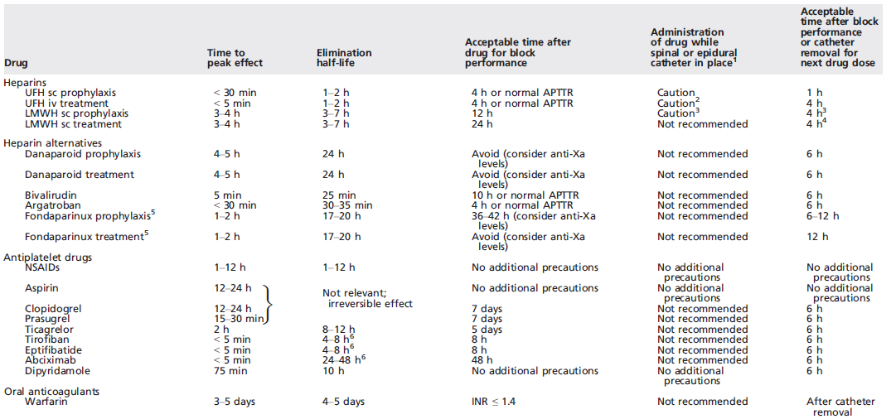

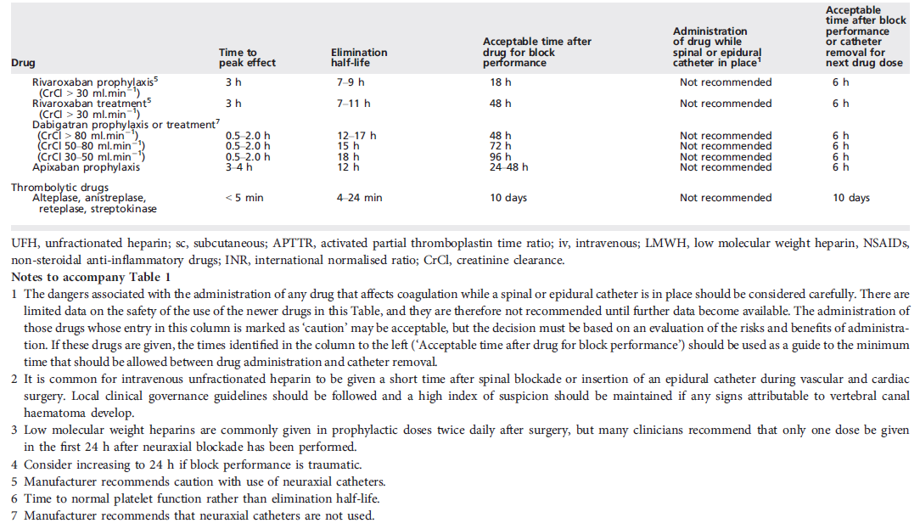

Ref: AAGBI (2013) – Regional Anaesthesia and Patients with Abnormalities of Coagulation

